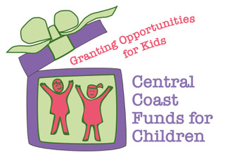
Grant Application Guidelines 2022

Guiding Mission Statement:
Central Coast Funds for Children, a non-profit corporation, is established to raise funds for children in need in San Luis Obispo County. All funds awarded must remain in San Luis Obispo County.

Due date: Applications must be received by September 30th

- Complete all sections the Grant Application Form found on the website.
- If the agency is a previous CCFC grant recipient, a CCFC Accountability Report (found on website) must be completed and submitted with the application.
- It is requested that the CCFC Grant Application Form and the CCFC Accountability Report on the website be used for submission.
- E-mail applications will NOT be accepted.
Submit application to :
CCFC Grant Review Chair (name and contact information is on the CCFC website) P.O. Box 1046
San Luis Obispo, CA 93406
- Keep to the limits on the length of the responses.
- Provide 7 copies of the application, 7 copies of the Accountability Report, and 7 copies of your Yearly Budget.
- All documents must be 3-hole punched and collated in this order:
Application Accountability Report Yearly Budget
- Grants will be awarded in December and agencies notified in January. You will also receive an invitation to our Supporter Luncheon in March.
Note: CCFC does NOT fund requests for:
- Transportation
- Salaries
- Operating costs
- Children over 18 years of age
- Services outside of San Luis Obispo County

